RSA Implementation Using FPGA

Nitin Singh
Department Of Electronics and Communication
JSS Academy Of Technical Education , Noida
20ec094@jssaten.ac.in
Riya Sharma
Department Of Electronics And Communication
JSS Academy Of Technical Education, Noida
20ec028@jssaten.ac.in
Nisha Chauhan
Department Of Electronics And Communication
JSS Academy Of Technical Education , Noida
20ec155@jssaten.ac.in

Abstract—This paper presents the design and implementation of a cryptographic technique, RSA that can be used as a standard in the secured communication system. The basic idea of this algorithm is to create a confidential communication channel in between two parties (sender, receiver). Each module (block) is coded using Verilog and the code is synthesized and simulated using Xilinx ISE_14.7 Design Suite. The design is optimized for speed and a tradeoff is presented between speed, power and space. FPGA is used as a hardware to increase the speed and make the algorithm more secured. As a major practical result, our aim is to show that it is possible to implement RSA[1] algorithm at secure bit lengths on a single commercially available hardware, FPGA and the study covers the design, optimization, and challenges of implementing RSA modules on FPGA, emphasizing modular exponentiation, key generation and data handling.
Keywords—Cryptography, Encryption, Decryption, RSA, Security, Verilog, FPGA.

Introduction
With the recent explosion of emerging technologies and electronic data communications, it is very important to develop new and better ways to guarantee the safety and security of the data that is being transferred. The art of keeping messages secure is termed as Cryptography [2]. Cryptography plays a vital role in data security. The RSA algorithm was introduced in the year 1978 by Ron Rivest, Adi Shamir and Leonard Adleman. It’s a public key cryptographic algorithm that’s high quality and very secured [3]. It is used as a method to exchange important information like keys and producing digital signatures. However, RSA operates on very large integers (typically thousands of bits long) [4]

STEPS OF SECURE CDOMMUNICATION (DATA TRANSFER)
RSA involves a public key and a private key. The public key is known to everyone and is used to encrypt messages. Messages that are encrypted with public key can only be decrypted using the private key. The keys are generated by the following steps:

1. Encryption
1.1 Key Generation (Public Key)[5]
2. Data Transfer
3. Decryption
3.1 Key Generation (Private Key)
III.ENCRYPTION
Encryption is a process that transforms plaintext into ciphertext, rendering information unintelligible to unauthorized users Crucial in ensuring confidentiality, integrity, and authenticity, encryption safeguards sensitive data from unauthorized access and tampering. Widely adopted in digital communication and storage, encryption plays a pivotal role in cybersecurity, offering a robust defense against unauthorized intrusion and data compromise.
KEY GENERATION
- Choose two distinct large random prime numbers p and q.
- Compute n = p*q. The number n is used as the modulus for both the public and private keys.
Compute the Euler’s function: ϕ (n) = (p −1) (q −1).
Choose an integer e such that 1<e< ϕ (n); e and ϕ
- (n) share no factors other than 1 (i.e. e and ϕ (n) are co primes); e is released as the public key exponent.
- Compute d for the congruence relation
de ≡ 1 (mod ϕ (n)) ; i.e. ed ≡ 1 (mod φ(n)) [6].

Majorly public exponent, e is taken as e=2^16 +1 =65537. Some applications choose smaller values like e= 3, 5, 17 or 257 instead. We do this to make encryption faster. The public key consists of the modulus n and the public exponent e. The private key consists of the modulus n and private exponent d.

DIVIDER 16 BITS
The division process involves dividing a larger binary number (dividend) by a smaller binary number (divisor) to obtain a quotient and a remainder. The 16-bit divider performs this operation on binary data of 16 bits each. The result of the division is typically a quotient and a remainder, both represented as 16-bit binary numbers. Here 16 bit divider is utilised in RSA cryptography (using FPGA) as:

Key Generation:
In the key generation phase of RSA, prime numbers are generated. The 16-bit divider could be used to check and ensure that the generated numbers are prime.
Encryption:
During the encryption process, the plaintext is typically raised to the power of the public exponent modulo the public modulus (n). The modular exponentiation involves multiple modular multiplications, where a 16-bit divider might be used to handle smaller chunks of the data efficiently.
Decryption:
In RSA decryption, the ciphertext is raised to the power of the private exponent modulo n. Similar to encryption, modular arithmetic with a 16-bit divider could be employed in this process.

DIVIDER 32 BITS

In RSA cryptography, a 32-bit divider is employed as part of the modular exponentiation operation, which is a fundamental operation in the RSA algorithm. Modular exponentiation involves raising a base number to the power of an exponent and taking the result modulo a modulus. This operation is expressed as c≡m^e mod n, where c is the ciphertext, m is the plaintext, e is the public exponent, and n is the modulus. Here 32 bit divider [7] is utilised in RSA cryptography(usingFPGA)as:

Modular Exponentiation:
The modular exponentiation operation in RSA requires multiple modular multiplications and divisions.
A 32-bit divider is used to efficiently compute the modular divisions within the RSA algorithm.

FPGA Implementation:
FPGAs are programmable hardware devices that can be configured to implement specific digital logic circuits.
The modular exponentiation operation, including the 32-bit divider, is implemented in hardware on the FPGA.

Security Considerations:
Implementing RSA on an FPGA requires attention to security considerations, such as protection against side-channel attacks.

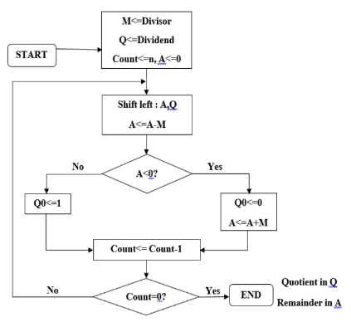
Fig 1 32 bit Divider Architecture

MODULAR MULTIPLIER
Modular multiplier is a pivotal component in achieving efficient modular exponentiation. This operation is integral to both RSA key generation and the encryption/decryption processes. In the modular exponentiation equation
m is the plaintext, e is the exponent, and n is the modulus, the modular multiplier plays a crucial role by ensuring that each multiplication operation is performed modulo n.

- Efficient Multiplication:
The modular multiplier performs multiplication of two numbers, typically the base m and the result from the previous modular multiplication step.This operation is conducted with the aim of minimizing computational complexity.
- Modular Reduction:
After multiplication, the result undergoes modular reduction by taking the remainder when divided by the modulus n.This step prevents numerical overflow and keeps the result within the appropriate range [0, n−1].
- Iterative Process:
The modular multiplier iterates over each bit of the exponent e, proceeding from the least significant bit (LSB) to the most significant bit (MSB).At each step, the result is accumulated.
- Impact on RSA Performance:
The efficiency of the modular multiplier directly influences the overall performance of RSA cryptography.
Key generation and encryption/decryption processes rely heavily on modular exponentiation, making the modular multiplier a critical factor.

IV. DECRYPTION

Decryption is the process of transforming encrypted data, known as ciphertext, back into its original and readable form, known as plaintext. The RSA algorithm relies on the mathematical properties of large prime numbers and involves a pair of keys: a public key for encryption and a private key for decryption.

Here's a step-by-step explanation of the decryption processin RSA:

Ciphertext Reception:

The recipient receives the ciphertext c transmitted securely over a communication channel.

Private Key Usage:

The recipient uses their private key d for decryption. The private key is a part of the key pair generated during the RSA key generation process.

V. RESULTS
ENCRYPTION
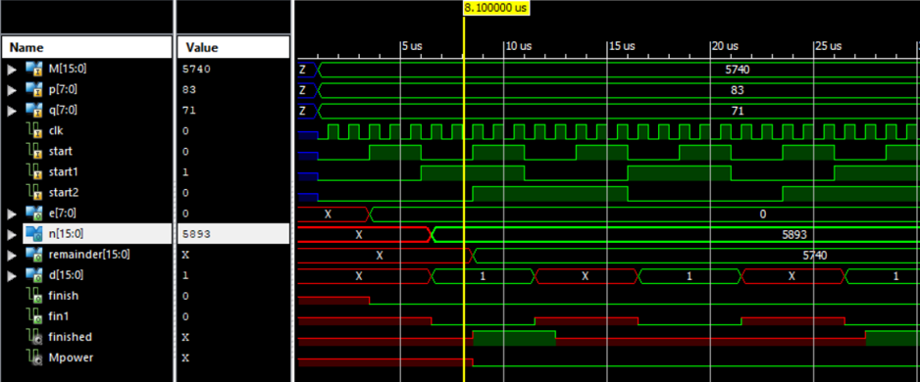

KEY GENRATION
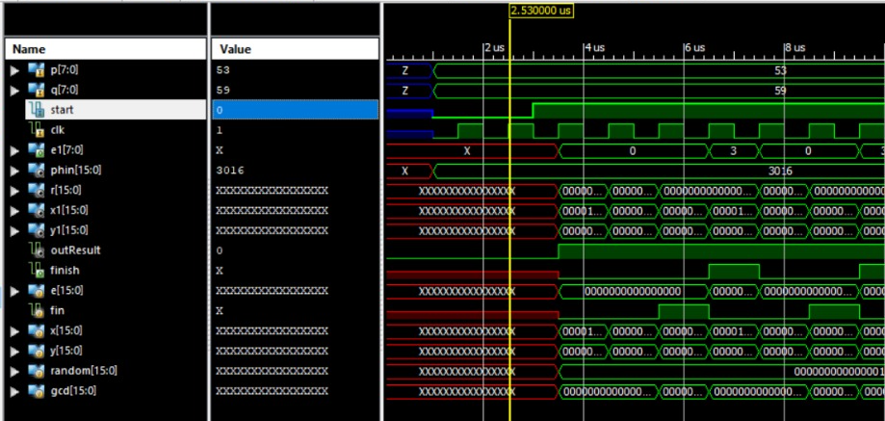

16-BIT DIVIDER
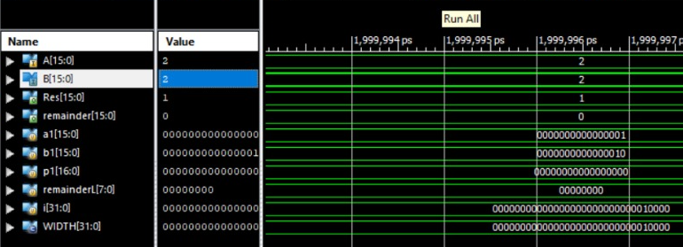

32-BIT DIVIDER
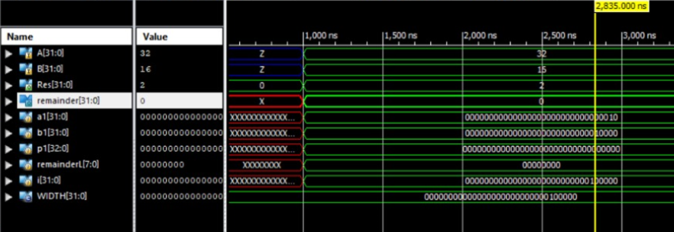

DECRYPTION
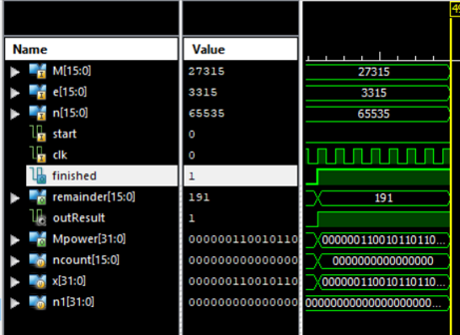

Acknowledgment
The preferred spelling of the word “acknowledgment” in America is without an “e” after the “g”. Avoid the stilted expression “one of us (R. B. G.) thanks ...”. Instead, try “R. B. G. thanks...”. Put sponsor acknowledgments in the unnumbered footnote on the first page.

References
- B. Steyn, "Essays: Doctrina.org," Doctrina.org, 26 May 2012. [Online]. Available: http://doctrina.org/How-RSA-Works-WithExamples.html. [Accessed 19 March 2017]
- Cetin Kaya Koc, High speed RSA algorithm, RSA laboratories, version 2, 1994
- G. C. Kessler, An Overview of Cryptography, Boca Raton: Auerbach Publications,2017.
- Perovic N.S; Popovic-Bozovic : “FPGA implementation of RSA crypto algorithm using shift and carry algorithm “,IEEE
- Lin X Sun L and Qu H, 2017 An efficient RSA-based certificateless public key encryption scheme.
- Meng X and Zheng X, 2015 Cryptanalysis of RSA with a small parameter revisited Inf. Process. Lett. 115, 11 p. 858–862.
- https://www.irjet.net/archives/V7/i9/IRJET-V7I9160.pdf

IEEE conference templates contain guidance text for composing and formatting conference papers. Please ensure that all template text is removed from your conference paper prior to submission to the conference. Failure to remove template text from your paper may result in your paper not being

